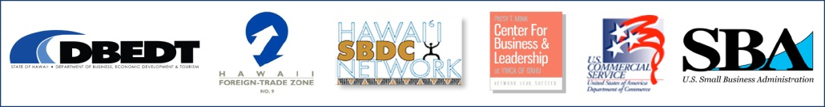

Name

Business

Address

City State Zip

Phone Fax

Email

Co-sponsorship Authorization #15-0951-93. *SBA‘s participation is not an endorsement of the views, opinions, products or services of any other person or entity. All SBA programs are extended to the public on a non-discriminatory basis. Reasonable arrangements for persons with disabilities will be made if requested at least two weeks in advance. Please call the SBA at 541-2990 to make arrangements.*

**Explore Exporting**

**Riding the Global Wave**

Is your company looking to grow, find new markets or expand your revenue stream? If so, this is the small business event for you! You will hear presentations on export financing, marketing, counseling and more. You will also be able to meet one-on-one with various export experts who can answer your export questions, such as:

* How to move your business into the international arena.
* How to meet overseas buyers
* How to finance your export and domestic transactions
* What are the International regulations, tariff requirements, and any other international business concerns?

On the morning of the workshop **between 8:30am – 8:45am**, you have the opportunity to sign up for free, one‑on-one confidential meetings with Business Counselors, local lenders, freight forwarders and others. The sign-up session will be on a first-come, first-served basis.

**Riding the Global Wave**

**9 am – Noon**

**Wednesday, May 27, 2015**

**Foreign Trade Zone #9, Suite M401**

Homer A. Maxey International Trade Resource Center

521 Ala Moana Boulevard

Honolulu, HI 96814

**Ample and free parking is available.**

**Don’t miss this free, informative workshop. Seating is limited and advanced registration is required by one of the following methods:**

* Call Mary Dale at (808) 541-2990 ext. 211 or email mary.dale@sba.gov
* Visit www.sba.gov/hi and click on the *Events Calendar*
* Complete the form below and fax to (808) 541-2976

Hawaii District Office

500 Ala Moana Blvd.

Suite 1-306

Honolulu, HI 96813

(808) 541-2990

<http://www.sba.gov/hi>

Every day, the U.S. Small Business Administration and its nationwide network of partners help millions of potential and current small business owners start, grow and succeed.

Resources and programs targeting small businesses provide an advantage necessary to help small businesses effectively compete in the marketplace and strengthen the U.S. economy.

SBA offers help in the following areas:

* Starting a Business
* Financing a Business
* Growing a Business
* Opportunities in Contracting
* Recovering from Disaster
* A Voice for Small Business in Gov’t.

Visit SBA online at http://www.sba.gov for 24/7 access to small business information, news and training for entrepreneurs.

All SBA programs and services are extended to the public on a nondiscriminatory basis.