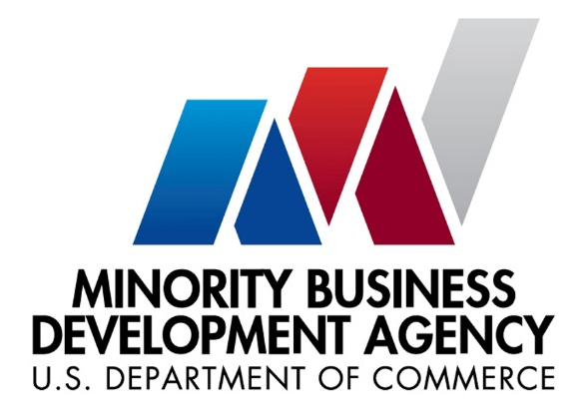
Business Check-Up Workshop
Wednesday, February 28, 2018
2:00 pm to 4:00 pm
Kapiolani Community College
Manono Building, Room 104

This workshop will provide you with tools, methods and probing questions to check up on how your business is doing so you can determine what you need to do to maintain and grow a profitable business. Business owners can get caught up in the day-to-day running of their business and not realize that they may:
• Pursue target markets that have changed and are no longer profitable;
• Not have the right equipment, people and facilities for their growth;
• Become outdated by competition tactics;
• Pursue pricing tactics that can lead to financial ruin.

The workshop will cover six areas of your business you should be reviewing every three months.
- Business Self Analysis – Monitor key areas that make or break a business
- Marketing Review – Industry Trends, Target Market Changes, Competition, Pricing and Promotional Strategies
- Operations/Management Check-Up – Manpower, Organization, Outside Resources, Facilities, Equipment
- Financial Condition – Actual Results to Projected, Trend Analysis & Industry Standards, Financial Ratio Analysis, Macro & Micro View: Margin Analysis, Pricing Strategy
- Profit Improvement Tools – Breakeven Analysis & Profit Improvement Ideas

REGISTRATION IS FREE! However, space is limited so please register at:
https://www.eventbrite.com/e/business-check-up-workshop-tickets-42957004557
For more information contact Michelle Clark at MLC@hawaii.edu or (808) 956-2502.
About the MBDA Business Center Honolulu:
The MBDA Business Center Honolulu, operated by the University of Hawai`i, is part of a national network of funded centers located throughout the United States. The centers foster the establishment and growth of minority-owned businesses in America by working with minority business enterprises to generate increased financing and contract opportunities and to create and retain jobs. Under cooperative agreement by the U.S. Department of Commerce, the center’s mission is to cultivate and support the entrepreneurial spirit in the Hawai`i minority community: its individuals, businesses, and organizations. Visit: http://honolulumbdacenter.com

