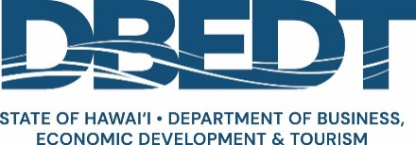

Japan Market Checklist, February 2024

Please answer the following as best as possible and return to lyle.h.fujikawa@hawaii.gov.

- Why Japan, why now?
- Is your product the most popular in Hawaiʻi, or best-selling in category?
- Does your brand have state-wide awareness and popularity?

- Why do you believe your products will sell to Japanese consumers?
- What concrete data or observations have you gathered?
- How much in sales have you made to Japanese consumers?
- How often have you made these sales?
- What kinds of products are you selling, and what are the benefits and features?

- How committed is the business?
- What research or validation have you conducted?
  - online research;
  - actual sales to Japanese consumers;
  - recent Japan visit for market research, trade show, other business?

- Do you have a basic export plan targeting Japan that outline:
- sales and marketing objectives;
- exporting actions;
- timeline to achieve goals;
- budget;
- success metrics?

- Do you have dedicated company resources, meaning team member(s) and budget?
- Are you able to communicate in Japanese, business or native level?

- Have you defined your target audience?
- Do you know your segmented target audience (demographics)?
- Do you understand their attitudes and behaviors (needs and wants, purchasing habits)?

- What products are you selling?
- What unique benefits do you offer to your target Japanese consumers?

- Can you develop and sell products to satisfy the needs and wants of Japanese consumers, at the right price point, but still make a profit?

- Do you have a Japanese importer to help gain import approval and import products into Japan?
- One importing company of record who can communicate well in English and support their goals and strategy;
- Food, alcoholic beverage, and skincare products require several other detailed checks;
- NOTE: Importers are usually not responsible for distribution (you would seek out other business partners), marketing (as the brand owner you would be responsible for budget, strategy and actions).

- What is your desired distribution channel? Do you understand the available opportunities?
- DBEDT-sponsored Consumer/Retail
  - Hankyu Hawaiʻi Fair
  - Hankyu Hawaiʻi Life online shopping and external fairs
  - Makuake pre-sales E-Commerce channel
  - Haneda pop-up or permanent store
- DBEDT-sponsored Trade/Wholesale
  - FoodEx Japan
  - Tokyo International Gift Show
- Others

